**Participants in the economy**

1. **Who are the four participants in the economy?**

|  |  |
| --- | --- |
| Households | Businesses |
| Financial (Banks) | Government |

1. **Complete this sentence**

The household sector is a term used by economists to refer to the total of all **consumers**  in the economy.

1. **What does the household sector provide to the business sector to produce goods and services?**

**……labour…………**

1. **Complete this sentence**

When buying goods and services, we are part of the household sector. When at work, we are part of the business sector.

1. **Complete the circular flow of money diagram between households and businesses**
2. **The resources of the business sector fit into four categories. What are they?**

|  |  |
| --- | --- |
| **Category 1 - Capital** | **Category 2 - Labour** |
| **Category 3 - Enterprise** | **Category 4 - Land** |

1. 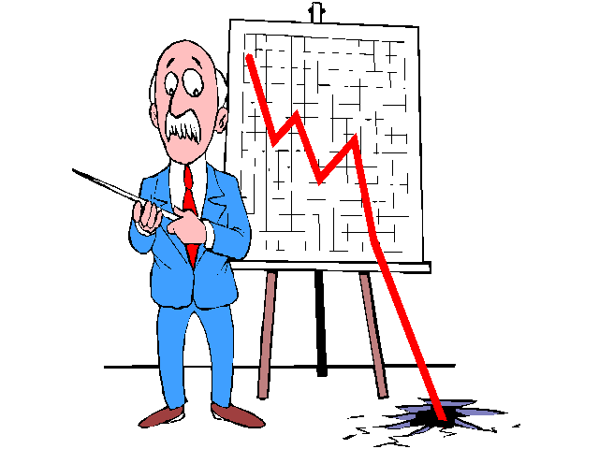**The government plays an important role in the economy. Complete these sentences**

The amount of money taken by the government in taxes can affect the amount of money consumers have available to spend on goods and services. Levels of taxation affects households and businesses.

Money collected in taxes from households and businesses can be used to **provide essential services** **such as roads , schools and hospitals** . This helps businesses to grow and employ more people.